**All about margin of error**

**Margin of error** is the maximum amount that the sample results are expected to differ from those of the actual population. More technically, the margin of error defines a range of values below and above the average result for the sample. The average result for the entire population is expected to be within that range. We can better understand margin of error by using some examples below.

**Margin of error in baseball**

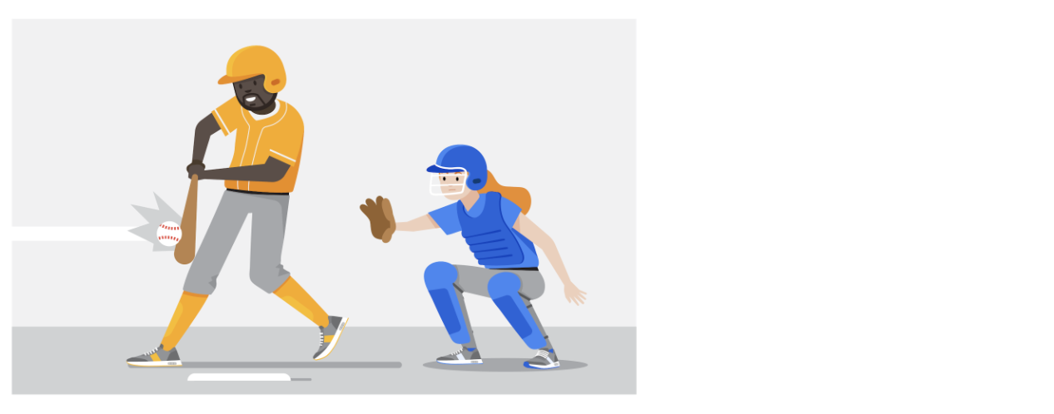

Imagine you are playing baseball and that you are up at bat. The crowd is roaring, and you are getting ready to try to hit the ball. The pitcher delivers a fastball traveling about 90-95mph, which takes about 400 milliseconds (ms) to reach the catcher’s glove. You swing and miss the first pitch because your timing was a little off. You wonder if you should have swung slightly earlier or slightly later to hit a home run. That time difference can be considered the margin of error, and it tells us how close or far your timing was from the average home run swing.

**Margin of error in marketing**

The margin of error is also important in marketing. Let’s use A/B testing as an example. **A/B testing** (or split testing) tests two variations of the same web page to determine which page is more successful in attracting user traffic and generating revenue. User traffic that gets monetized is known as the **conversion rate**. A/B testing allows marketers to test emails, ads, and landing pages to find the data behind what is working and what isn’t working. Marketers use the **confidence interval** (made up of the conversion rate and the margin of error) to understand the results.

For example, suppose you are conducting an A/B test to compare the effectiveness of two different email subject lines to entice people to open the email. You find that subject line A: “Special offer just for you” resulted in a 5% open rate compared to subject line B: “Don’t miss this opportunity” at 3%.

Does that mean subject line A is better than subject line B? It depends on your margin of error. If the margin of error was 2%, then subject line A’s actual open rate is somewhere between 3% and 7%. Since the lower end of the range overlaps with subject line B’s results at 3%, you can’t conclude that there is a statistically significant difference between subject line A and B. Examining the margin of error is important when making conclusions based on your test results.

**Want to calculate your margin of error?**

All you need is population size, confidence level, and sample size. In order to better understand this calculator, review these terms:

* **Confidence level**:The probability that your sample accurately reflects the greater population
* **Population**: The total number you pull your sample from
* **Sample**: A part of a population that is representative of the population
* **Margin of error**: The maximum amount that the sample results are expected to differ from those of the actual population

In most cases, a 90% or 95% confidence level is used. But, depending on your industry, you might want to set a stricter confidence level. A 99% confidence level is reasonable in some industries, such as the pharmaceutical industry.

After you have settled on your population size, sample size, and confidence level, plug the information into a margin of error calculator like the ones below:

* [Margin of error calculator by G​ood Calculators (free online calculators)](https://goodcalculators.com/margin-of-error-calculator/)
* [Margin of error calculator by CheckMarket](https://www.checkmarket.com/sample-size-calculator/#sample-size-margin-of-error-calculator)

**Key takeaway**

Margin of error is used to determine how close your sample’s result is to what the result would likely have been if you could have surveyed or tested the entire population. Margin of error helps you understand and interpret survey or test results in real-life.  Calculating the margin of error is particularly helpful when you are given the data to analyze. After using a calculator to calculate the margin of error, you will know how much the sample results might differ from the results of the entire population.